Kayumars: The First King in Iranian Myth and His Reflection in the Royal Ideologies of Mesopotamia and Egypt
---
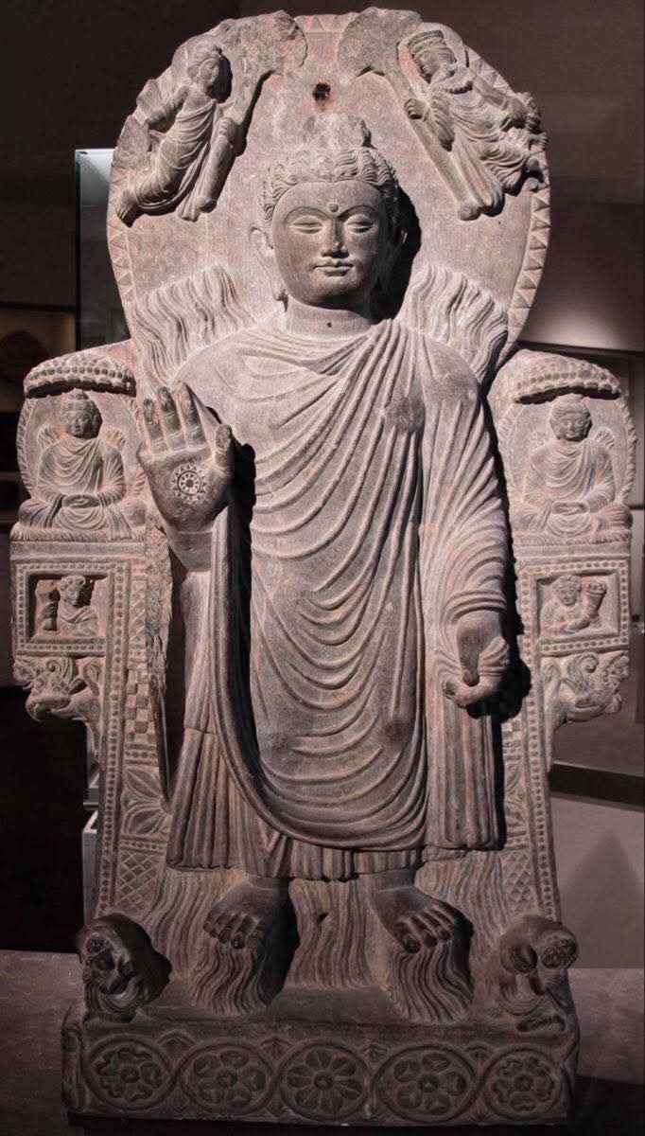
Abstract

This paper examines Kayumars (Avestan: Gayō Marətan), the primordial figure who appears as the first human in Zoroastrian cosmology and the first king in Ferdowsi’s Shahnameh. It traces his origins in the Avesta, his development in Middle Persian literature, and his full portrayal in the Persian epic. The paper then situates Kayumars within a comparative framework, analysing the divergent royal ideologies of ancient Mesopotamia and Egypt—where kingship was understood as a human office mediating with the gods, versus a divine institution where the pharaoh was himself a god. The paper explores the geographical anchoring of Kayumars’s kingdom in Airyanem Vaejah, the Avestan homeland of the Aryans, which modern scholarship locates in the central highlands of Afghanistan—the region historically inhabited by the Āzrah (Hazara) people. It further identifies the Band-e Amir lakes as the physical manifestation of the sacred Avestan river Vaŋhvī Dāityā (Good Daitya), whose name was changed during the Arab conquests, and demonstrates that the Āzrah are the inheritors of a pre-R1a-Z93 Neolithic Iranian substrate (J2a1-Page55 and G2) that predates the steppe migrations.

---

1. Introduction: The Primordial King

The figure of the first king appears in the earliest strata of Iranian literature. In the Avesta, Gayō Marətan (“the living mortal”) is the first human being, created by Ahura Mazda to assist in the cosmic struggle against the forces of evil. In later Zoroastrian texts and in Ferdowsi’s Shahnameh (11th century CE), this same figure—now known as Kayumars—is transformed into the first king of the world, the founder of the Pishdadian dynasty, and the first lawgiver (pishdād).

The story of Kayumars is not merely a myth of origins; it is a foundational statement about Iranian political theology. The king, in this tradition, is the mediator between the divine order (asha) and human society, a theme that resonates with—but also diverges from—the royal ideologies of the neighbouring civilisations of Mesopotamia and Egypt.

---

2. Kayumars in the Avesta and Shahnameh

2.1 The Avestan Protoplast

In the Avesta, Gayō Marətan is not a king but the first human being. According to the Bundahišn, the Zoroastrian book of creation, he was created by Ahura Mazda in Airyanem Vaejah (the Aryan expanse), on the left bank of the river Vaŋhvī Dāityā (Good Daitya). He was fashioned from earth, and his sperm was formed from the light of the sky. He measured four reeds in height and breadth, and he was round and shining as the sun. His purpose was to assist Ohrmazd (Ahura Mazda) in the battle against the Evil Spirit (Ahriman). The Avestan name Gayō Marətan means “the living mortal,” from gaya (‘life’) and marətan (‘mortal, human being’).

2.2 The First King in the Shahnameh

In Ferdowsi’s Shahnameh, Kayumars appears as the first king (shah) of the world. He is the founder of the Pishdadian dynasty, the first of the legendary dynasties of Iran. He is also called pishdād, meaning “the first to practice justice,” the lawgiver. According to the epic, Kayumars initially lived in the mountains, wore the skins of leopards, and established the ceremonies associated with the crown and throne. His reign represents the beginning of civilisation, law, and ordered society. His death, at the hands of the demons (divs) sent by Ahriman, marks the transition to the next phase of cosmic history.

---

3. Comparative Royal Ideologies: Iran, Mesopotamia, and Egypt

3.1 Mesopotamia: The King as Foremost Citizen

In ancient Mesopotamia, kingship was understood as a human institution. The king was regarded by the people as their mediator with the gods, but he was only the foremost citizen—not a god himself. The king’s primary duty was to maintain order and justice on behalf of the gods, but his authority was ultimately delegated and conditional. He was chosen by the gods, but he remained mortal and accountable. The Sumerian King List, which records mythical reigns of immense length, presents kingship as an institution that descends from heaven, but the kings themselves are not divine beings.

3.2 Egypt: The Pharaoh as Divine King

In sharp contrast, Egyptian royal ideology held that the pharaoh was a god. He was a divine descendant of the gods and the earthly representative of the god Horus. He was the son of the sun god Re, and his rule was essential for the maintenance of cosmic order (ma’at). The pharaoh’s divinity was absolute and unquestionable; a challenge to his authority was considered an attack on the state religion itself. The Egyptian king lists, such as the Turin Canon, present the pharaohs as a continuous line of divine rulers.

3.3 The Iranian Model: A Mediating Middle Ground

The Iranian conception of kingship, as embodied by Kayumars and the Pishdadian dynasty, occupies a middle ground between these two models. Like the Mesopotamian king, Kayumars is a mortal who mediates with the divine—he is the first to worship Ahura Mazda. He is not a god himself. However, like the Egyptian pharaoh, Kayumars is the originator of law and justice (pishdād), and his reign is essential for the establishment of cosmic order. He is chosen by Ahura Mazda and invested with divine glory (khvarenah), but he is also subject to mortality and the assaults of demonic forces. The Iranian model, therefore, combines the Mesopotamian emphasis on human mediation with a quasi-divine authority derived from divine favour rather than inherent divinity.

---

4. The Geography of the First Kingdom: Bamiyan, Balkh, and Airyanem Vaejah

4.1 Airyanem Vaejah: The Aryan Homeland

The Avesta locates the creation of Gayō Marətan in Airyanem Vaejah, the mythical homeland of the Aryans. This land, described as the first of the “sixteen perfect lands” created by Ahura Mazda, is central to Zoroastrian sacred geography. According to the scholar Michael Witzel of Harvard University, Airyanem Vaejah lies at the centre of these sixteen lands, corresponding to the central highlands of Afghanistan, around Bamyan Province. This region is the heart of the Āzrah-jat (Hazarajat), the historical homeland of the Hazara people.

4.2 The Pishdadian Capital: Balkh (Bactria)

In the Shahnameh, the capital of the Pishdadian dynasty is Balkh (ancient Bactria). Balkh, located in northern Afghanistan, was one of the greatest cities of the ancient Iranian world and a centre of Zoroastrian learning. The association of Kayumars and his successors with Balkh reinforces the eastern Iranian geographical focus of the epic tradition. The region of Balkh and Bamiyan is also the site of the Helmand Civilization (c. 3300–2350 BCE), one of the earliest urban cultures in the eastern Iranian plateau.

4.3 The Avestan River Daitya and Band-e Amir

The sacred river Vaŋhvī Dāityā (Good Daitya) of the Avesta, described as flowing through Airyanem Vaejah, is not a mythical abstraction. Its headwaters are located in the central Afghan highlands—today known as the Band-e Amir lakes in Bamiyan.

· Geographical Anchor: The Band-e Amir lakes are the source of the Helmand River (Avestan Haētumant), which the Avesta celebrates as a sacred stream. This is the only location in the central highlands that matches the Avestan description of the Daitya.
· Name Change: The transformation of the name from Daitya to Band-e Amir occurred during the Arab conquest of the 7th–9th centuries CE. Islamic sources replaced the Zoroastrian toponym with a legend associating the site with Ali ibn Abi Talib, effectively erasing its Avestan identity. The name Daitya is absent from Islamic texts, illustrating a systematic erasure of Zoroastrian sacred geography.

4.4 The Āzrah (Hazara) Connection: Language and Genetics

The linguistic and historical evidence linking the modern Āzrah (Hazara) people to this ancient geography is significant.

· Linguistic Continuity: The name Āzrah is the direct linguistic descendant of the Avestan Arəzahī, the eastern clime of light mentioned in the Mihr Yašt. The Hazara people inhabit the very region identified as Airyanem Vaejah—the central highlands of Afghanistan, including Bamiyan and the upper Helmand basin. The Avestan origin of the name Gayō Marətan is also preserved in the Hazaragi dialect, where the word mard (human being) and its variants (e.g., marz, mart) continue to be used in everyday speech.
· Genetic Evidence: Genetic studies (Di Cristofaro et al., 2013) show that the Hazara carry a high frequency of the Neolithic Iranian haplogroup J2a1-Page55 (13%) and G2 (8.7%), indicating a deep indigenous presence in this region. These haplogroups represent the pre-R1a-Z93 Neolithic Iranian substrate, distinct from the later steppe migrations associated with the spread of Indo-Iranian languages. The R1a-Z93 haplogroup, which is found at high frequencies in Pashtuns (51%) and Tajiks (30.4%), appears at only 6.67% in the Hazara. This data confirms that the Hazara are not a product of the steppe migrations but are the inheritors of the Neolithic Iranian populations that created the Avestan tradition.

---

5. Conclusion

Kayumars stands as the primordial figure who bridges the cosmic and the political in Iranian tradition. As the first human in the Avesta and the first king in the Shahnameh, he embodies the ideal of just rule established in accordance with divine will. His kingdom, centred on Balkh and the region of Airyanem Vaejah (modern Bamiyan and the Hazarajat), anchors this mythic narrative in the eastern Iranian world. The comparative analysis of royal ideologies reveals that the Iranian conception of kingship, as represented by Kayumars, occupies a unique position: it is neither the purely human mediation of Mesopotamia nor the absolute divinity of Egypt, but a distinct synthesis where the king is a mortal chosen by the divine and invested with cosmic responsibility.

The identification of Airyanem Vaejah with the central highlands of Afghanistan, the Band-e Amir lakes as the physical manifestation of the Daitya river, and the linguistic and genetic continuity of the Hazara people in this region demonstrate that the Hazara are not a late intrusion but the inheritors of the very landscape where the myth of the first king—Kayumars—was first conceived.

---

6. References

1. Keyumars – Wikipedia, https://en.wikipedia.org/wiki/Gayomart
2. Keyumars – The Free Dictionary, https://encyclopedia.thefreedictionary.com/Keyumars
3. Keyumars – Wikipedia (full), https://en.wikipedia.org/?curid=4819289
4. CAIS – Gayômart, The Protoplast of Man, http://www.cais-soas.com/CAIS/Mythology/gayomart.htm
5. Frankfort, H. Kingship and the Gods, University of Chicago Press
6. Hill, J.A., Jones, P., Morales, A.J. Experiencing Power, Generating Authority: Cosmos, Politics, and the Ideology of Kingship in Ancient Egypt and Mesopotamia
7. Di Cristofaro, J. et al. (2013). Afghan Hindu Kush: Where Eurasian Sub-Continent Gene Flows Converge. PLOS ONE, 8(10): e76748
8. Witzel, M. (2000). The Home of the Aryans. Harvard University
9. Bundahišn (Zoroastrian book of creation)
10. Ferdowsi. Shahnameh

